**Setting up Apache Web Server for Raspberry Pi**

**Version: 01**

**6/13/2015**

**Author: Rishi Thakkar**

**Contents**

1. Installing Apache Web Sever 3

1.1 Steps 3

1.2 Directory Setup 3

2. phpMyAdmin 4

2.1 Steps 4

3. Password Protecting directory with .htaccess 5

3.1 Steps 5

4. SSL Setup 5

4.1 Steps 5

5. Helpful Websites 6

# Installing Apache Web Sever

1. Steps

First thing that needs to be done is to install the following things using the command:

sudo apt-get install apache2 php5 libapache2-mod-php5

Once this is done everything is basically setup and ready to go. The only thing that needs to be done for good measure is to restart the apache server. Use the following code to do this:

sudo service apache2 restart

Now you are completely done with the setting up stage.

1. Directory Setup

www/

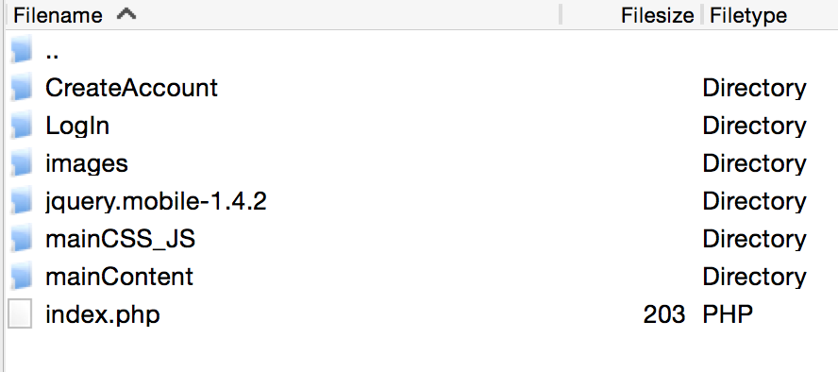

CreateAccount/

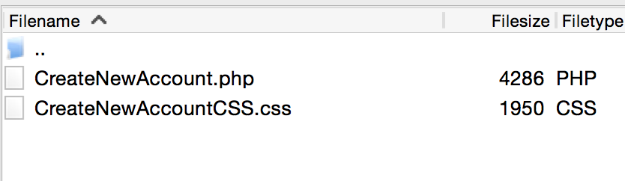

LogIn/

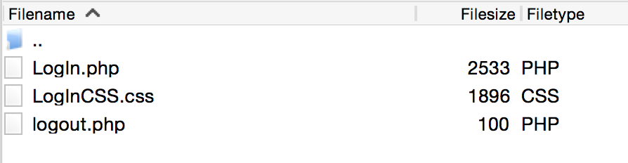

mainCSS_JS/CSS/

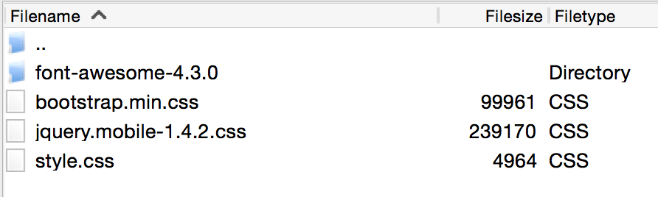

mainCSS_JS/JS

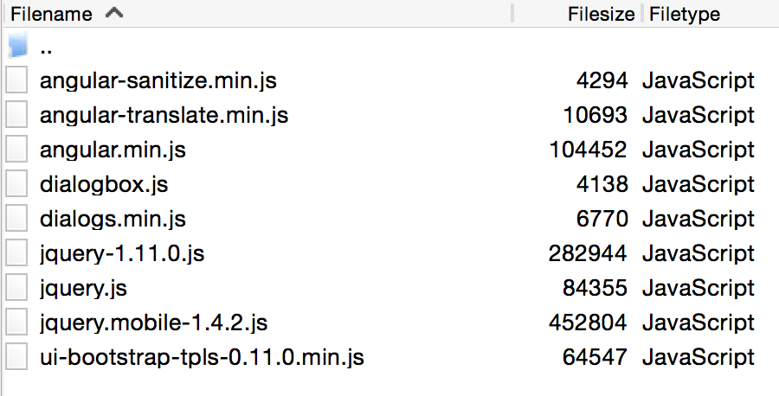

mainContent/

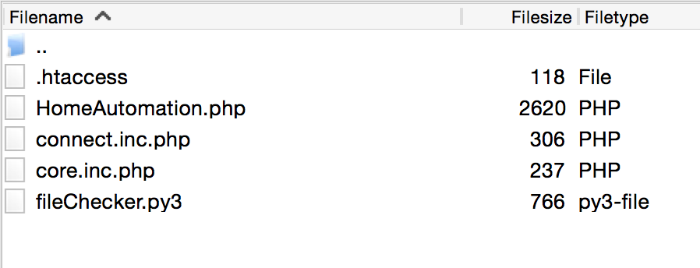

SERVER:

/etc/apache2

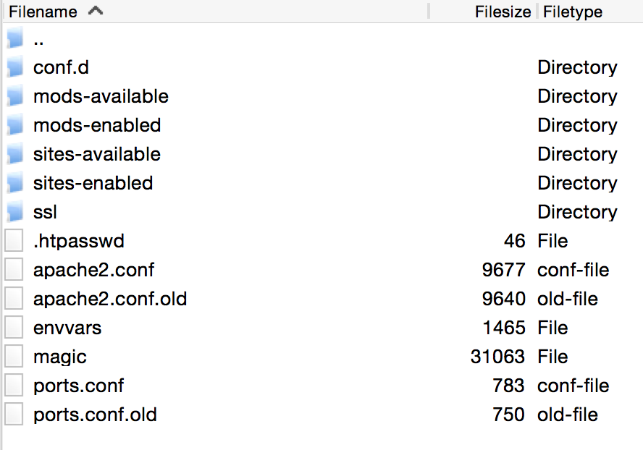

**.htpasswd has been placed in this location**

# phpMyAdmin

Website used: <https://www.youtube.com/watch?v=1uq1-sA9zhE>

1. Steps
2. Type into terminal: sudo apt-get install mysql-server
3. Type into terminal: sudo apt-get install phpmyadmin
4. Select apache2 when prompted for the first time
5. Say yes if asked if you want to configure the database
6. Type in password for the next two prompts
7. There might be some errors but you can ignore them for the most part
8. Go to IP/phpmyadmin/
9. No your databases are ready to go

# Password Protecting directory with .htaccess

Website used: <https://www.youtube.com/watch?v=yR05IQrzGfI>

1. Steps
2. install vim
3. open file: /etc/apache2/conf.d/security
4. Add the piece of code seen below in any location of this file: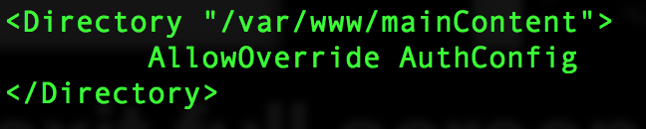
5. Switch directory to: /var/www/mainContent
6. Create a hidden file called .htaccess
7. In .htaccess, put the code you see below:

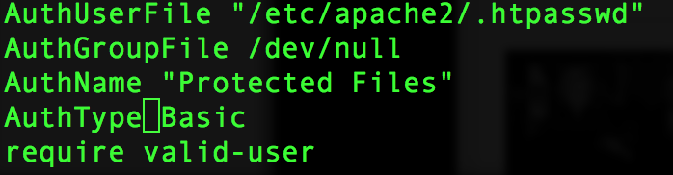

1. Switch directory to: /etc/apache2
2. Create .htpasswd file by typing: 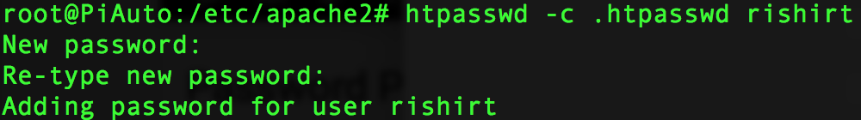
3. You are now ready to go. You can go to the protected website and it will be restricted.

# SSL Setup

Website used: <https://www.digitalocean.com/community/tutorials/how-to-create-a-ssl-certificate-on-apache-for-debian-7>

1. Steps
2. Run: sudo a2ensite default-ssl
3. Run: sudo a2enmod ssl
4. restart apache server
5. Change port listen to 443 from 80 in /etc/apache2/port.conf
6. Make directory: sudo mkdir /etc/apache2/ssl
7. Run to create self signed certificate:

sudo openssl req -x509 -nodes -days 10000 -newkey rsa:2048 -keyout /etc/apache2/ssl/apache.key -out /etc/apache2/ssl/apache.crt

-------- This will generate both the certificate and a public key

1. Restart apache
2. Go to the website for finishing touches

# Helpful Websites

Window 1

Access Control - Apache HTTP Server Version 2.2

http://httpd.apache.org/docs/2.2/howto/access.html

Authentication and Authorization - Apache HTTP Server Version 2.2

http://httpd.apache.org/docs/2.2/howto/auth.html

Password Protecting A Website in Apache Web Server - YouTube

https://www.youtube.com/watch?v=yR05IQrzGfI

Linux Tutorial - Apache Web Login Authentication:

http://www.yolinux.com/TUTORIALS/LinuxTutorialApacheAddingLoginSiteProtection.html

Cut and Paste JavaScript-Password protected page

http://www.javascriptkit.com/script/cut10.shtml

security - Best way to store password in database - Stack Overflow

http://stackoverflow.com/questions/1054022/best-way-to-store-password-in-database

Create Login Form Access Database Part 1 - YouTube

https://www.youtube.com/watch?v=sWsTwYuWc1o

ProgrammingKnowledge - YouTube

https://www.youtube.com/user/ProgrammingKnowledge/playlists

Beginner SQLite Tutorials - YouTube

https://www.youtube.com/playlist?list=PLS1QulWo1RIa0-Cs2Qx6GFyiIVVVS9lCS

Microsoft Access Database Tutorial for beginner - YouTube

https://www.youtube.com/playlist?list=PLS1QulWo1RIY0ijYy9qcXoo3lioUKtRsZ

Window 2

SSL/TLS Strong Encryption: How-To - Apache HTTP Server Version 2.4

http://httpd.apache.org/docs/2.4/ssl/ssl_howto.html

Passwords, Hashes and Salt (ITS335, Lecture 8, 2013) - YouTube

https://www.youtube.com/watch?v=M7SWzGi0a50

Beginner PHP Tutorial - 108 - An Introduction to Databases - YouTube

https://www.youtube.com/watch?v=83pUFQc6yW8&index=108&list=PL442FA2C127377F07

Beginner PHP Tutorial - 136 - Logging the User In Part 1 - YouTube

https://www.youtube.com/watch?v=mRmLkzrfDzU&list=PL442FA2C127377F07&index=136

Beginner PHP Tutorial - 151 - SQL Injection Part 1 - YouTube

https://www.youtube.com/watch?v=L41oWB4I1po&list=PL442FA2C127377F07&index=151

Beginner PHP Tutorial - 148 - More Validation Part 1 - YouTube

https://www.youtube.com/watch?v=xSMLhdwdoQo&index=148&list=PL442FA2C127377F07

Window 3

https raspberry pi - YouTube

https://www.youtube.com/results?search_query=https+raspberry+pi

Raspberry Pi - How to put your Pi Online - YouTube

https://www.youtube.com/watch?v=G0Lg4O-eeRQ

Setting up a secure website with HTTPS and SPDY support under nginx on a Raspberry Pi | Matt Wilcox, Web Developer & Tinkerer

https://mattwilcox.net/web-development/setting-up-a-secure-website-with-https-and-spdy-support-under-nginx-on-a-raspberry-pi

Setting up a (reasonably) secure home web-server with Raspberry Pi | Matt Wilcox, Web Developer & Tinkerer

https://mattwilcox.net/web-development/setting-up-a-secure-home-web-server-with-raspberry-pi

Securing Your Server - Linode Guides & Tutorials

https://www.linode.com/docs/security/securing-your-server/

cron job - Google Search

https://www.google.com/search?q=chorn+job&oq=chorn+job&aqs=chrome..69i57.2722j0j7&sourceid=chrome&es_sm=0&ie=UTF-8#q=cron+job

Window 4

http://cssdeck.com/picks/2 is not available

http://cssdeck.com/picks/2

password protecting apache server - Google Search

https://www.google.com/webhp?sourceid=chrome-instant&ion=1&espv=2&es_th=1&ie=UTF-8#q=password+protecting+apache+server

apache server password proctection - YouTube

https://www.youtube.com/results?search_query=apache+server+password+proctection

Window 5

ESP8266 - ElectroDragon

http://www.electrodragon.com/w/ESP8266#Setup_Check_list

nodemcu syntax - Google Search

https://www.google.com/webhp?sourceid=chrome-instant&ion=1&espv=2&es_th=1&ie=UTF-8#q=nodemcu%20syntax&es_th=1

nodemcu/nodemcu-firmware

https://github.com/nodemcu/nodemcu-firmware

nodemcu_api_en · nodemcu/nodemcu-firmware Wiki

https://github.com/nodemcu/nodemcu-firmware/wiki/nodemcu_api_en#noderestart

nodemcu-firmware/make_phone_call.lua at master · nodemcu/nodemcu-firmware

https://github.com/nodemcu/nodemcu-firmware/blob/master/lua_examples/make_phone_call.lua

nodemcu-firmware/send_text_message.lua at master · nodemcu/nodemcu-firmware

https://github.com/nodemcu/nodemcu-firmware/blob/master/lua_examples/send_text_message.lua

c# - what the difference between webrequest and httpwebrequest - Stack Overflow

http://stackoverflow.com/questions/4457791/what-the-difference-between-webrequest-and-httpwebrequest

Lua 5.2 Tutorial 1: Getting Started - YouTube

https://www.youtube.com/watch?v=Us46grT9wsA&index=17&list=PL0o3fqwR2CsWg_ockSMN6FActmMOJ70t_

http://www.youtube.com/ is not available

http://www.youtube.com/

Window 6

PASSWORD - webiopi - Internet of Things framework - Google Project Hosting

https://code.google.com/p/webiopi/wiki/PASSWORD

HTML5 Tutorial - 19 - Finishing up the Flexible Box Model - YouTube

https://www.youtube.com/watch?v=s_4zvAMU4BY&list=PL081AC329706B2953&index=19

jQuery Tutorial - 1 - Introduction to jQuery - YouTube

https://www.youtube.com/watch?v=GNb8T5NBdQg&list=PL6B08BAA57B5C7810&index=1

Beginner PHP Tutorial - 4 - Creating Your First PHP File - YouTube

https://www.youtube.com/watch?v=7NuTyB8Ypxc&index=4&list=PL442FA2C127377F07

Making Raspberry Pi Web Controls - YouTube

https://www.youtube.com/watch?v=EAMLwbShFFQ

Window 7

Lab Material – PHY203 Physics III: Thermal and Quantum ...

https://harper.blackboard.com/webapps/blackboard/content/listContent.jsp?course_id=_94323_1&content_id=_3527222_1

Window 8

Home Automation

file:///C:/Users/Rishi/Documents/Projects/_ECEProjects/ECE%20Projects/Home%20Automation%20Projects/Website%20-%20Control%20Hub/Flexible%20Model/Flexible%20Model_v02/HomeAutomationHTML.html

5ky.me/media/poll.py.txt

http://5ky.me/media/poll.py.txt

5ky.me/media/test.php.txt

http://5ky.me/media/test.php.txt

5ky.me/media/controller.php.txt

http://5ky.me/media/controller.php.txt

Window 9

Cheap and Easy WiFi (IoT) Tutorial Part 1 - ESP8266 Setup/Intro - YouTube

https://www.youtube.com/watch?v=qU76yWHeQuw

Cheap and Easy WiFi (IoT) Tutorial Part 2 - ESP8266 Arduino Code - YouTube

https://www.youtube.com/watch?v=zGgUfAB4m24

ESP8266 Send Data To a Website (ESP-01/ESP-12) - YouTube

https://www.youtube.com/watch?v=q02f4sPghSo&list=PLmfT_cdP5PYDRYIvGIQ4YQYnEprshtxO8&index=2

ESP8266 | Hackaday

http://hackaday.com/tag/esp8266/

ESP8266 Arduino Code and 3.3V Schematic to Send and Receive Data

http://allaboutee.com/2014/12/27/esp8266-arduino-code-and-circuit/

File:ESP8266 V091.png - ElectroDragon

http://www.electrodragon.com/w/File:ESP8266_V091.png

ESP8266 - Burn NodeMCU, write lua script, and control the water heater

http://www.whatimade.today/esp8266-and-the-water-heater/

Flashing Nodemcu firmware on ESP8266 using Windows Lua firmware

http://www.whatimade.today/loading-the-nodemcu-firmware-on-the-esp8266-windows-guide/

ESP8266 Community Forum Index page

http://www.esp8266.com/

ESP8266 - Easiest way to program so far (Using Arduino IDE)

http://www.whatimade.today/esp8266-easiest-way-to-program-so-far/

Window 10

C Programming Tutorial 29 - Course Project Solution 1 - YouTube

https://www.youtube.com/watch?v=rwIcz60Igo4&list=PLQndNexFjUWnRdVNiyFf9u2aO0o1CqS8G&index=29

C Programming Tutorial 30 - Loops - YouTube

https://www.youtube.com/watch?v=yHmGs04dQjI&list=PLQndNexFjUWnRdVNiyFf9u2aO0o1CqS8G&index=30

Conditional Execution

http://www.le.ac.uk/users/rjm1/cotter/page_34.htm

Comparing characters in c? - Stack Overflow

http://stackoverflow.com/questions/3911653/comparing-characters-in-c

Window 11

Homework Assignment 2 (Ch. 17 pt.2)

http://www.webassign.net/web/Student/Assignment-Responses/submit?dep=11450484#Q2

Course Materials – PHY203 Physics III: Thermal and ...

https://harper.blackboard.com/webapps/blackboard/content/listContent.jsp?course_id=_94323_1&content_id=_3527189_1&mode=reset

Lab data - rrthakk2@illinois.edu - Google Apps @ Illinois Mail

https://mail.google.com/mail/u/1/#inbox/14d6f4eb789ca0b0?projector=1

Window 12

Page Not Found - CITES Wiki

https://wiki.cites.illinois.edu/wiki/display/ece120/Weeks

Lab 1 - ECE 120 - Introduction to Computing - CITES Wiki

https://wiki.cites.illinois.edu/wiki/display/ece120/Lab+1

Homework 1 - ECE 120 - Introduction to Computing - CITES Wiki

https://wiki.cites.illinois.edu/wiki/display/ece120/Homework+1

Control Systems Lectures - Closed Loop Control - YouTube

https://www.youtube.com/watch?v=O-OqgFE9SD4&index=2&list=PLUMWjy5jgHK1NC52DXXrriwihVrYZKqjk

CS173 Lectures

https://courses.engr.illinois.edu/cs173/sp2015/A-lecture/Lectures/index.html

Window 13

Brushless DC Motors and Brushed DC Motors explained - BLDC Fan (2) - YouTube

https://www.youtube.com/watch?v=C1-klL3B9LU&list=PLxaGnte1Dq0kMFfzMfoNPzpe1JmMoqG-w&index=2

stepper motors explained - YouTube

https://www.youtube.com/results?search_query=stepper+motors+explained

bipolar stepper motors animation - YouTube

https://www.youtube.com/results?search_query=bipolar+stepper+motors+animation

Stepper Motor - 4 Wire Unipolar?

http://forum.arduino.cc/index.php?topic=20243.0

www.mitsumi.co.jp/latest/Catalog/pdf/motor_m35sp_9_e.pdf

http://www.mitsumi.co.jp/latest/Catalog/pdf/motor_m35sp_9_e.pdf

Stepping motor running without driver circuit - YouTube

https://www.youtube.com/watch?v=kAyDmovM18E

ohms - Google Search

https://www.google.com/search?q=ohms&oq=ohms&aqs=chrome..69i57j0l5.483j0j7&sourceid=chrome&es_sm=93&ie=UTF-8

Window 14

Declaring and using integer types from the Course C Essential Training

http://www.lynda.com/C-tutorials/development-environment-used-course/164457/180334-4.html

C Programming Tutorial - 8 - String Terminator - YouTube

https://www.youtube.com/watch?v=LEHaSSYreeo&list=PL6gx4Cwl9DGAKIXv8Yr6nhGJ9Vlcjyymq&index=8

Window 15

Blackboard Learn

https://harper.blackboard.com/webapps/login/?new_loc=%2Fwebapps%2Fblackboard%2Fcontent%2FlistContent.jsp%3Fcourse_id%3D_94323_1%26content_id%3D_3527222_1

Signed Binary Numbers - YouTube

https://www.youtube.com/watch?v=2WACEcDhQfs&index=9&list=PL455C7CE29B7DCC84

Window 16

8x8x8 Blue LED Cube part 1 - In the beginning - YouTube

https://www.youtube.com/watch?v=SqyO7OtqmFg&list=PL-xZsBalytNBI9KC3nuA_Jo6j9hP-5_9D

$3 Wifi module part 2: ThingSpeak Demo - YouTube

https://www.youtube.com/watch?v=Kg4S9OK65qc&list=PL-xZsBalytNAFgyiDI8_lwXyeVE3R4hpx&index=2

HariFun#104 - Raspberry Pi + ESP8266 Part 2 - Wiring - YouTube

https://www.youtube.com/watch?v=TkLOAvP5G1A&index=2&list=PL-xZsBalytNBQ5o-slHUQH7ijbhq5HaC_

http://raspberrypi-e9fdkwwcfm/ is not available

http://raspberrypi-e9fdkwwcfm/

Window 17

Raspberry Pi Web Server Tutorial - YouTube

https://www.youtube.com/watch?v=W2F8Wa65_B4

Tinkernut - Weekend Hacker: Make A Raspberry Pi Web Server - YouTube

https://www.youtube.com/watch?v=WgcNBjIJNYs

XHTML and CSS Tutorials Playlist - YouTube

https://www.youtube.com/playlist?list=PLC1322B5A0180C946

HTML5 Tutorial - 22 - Crazy Transformations - YouTube

https://www.youtube.com/watch?v=jRWGqBUNk_c&list=PL081AC329706B2953&index=22

Rishi's Website

file:///C:/Users/Rishi/Documents/Projects/_CSProjects/CS%20Projects/_HTMLTutorialProjects/22_Animations/Animations.html

Totally Tooling Tips: Sublime Text Plugins - YouTube

https://www.youtube.com/watch?v=2eu23_if6Lw

Window 18

Demo Flexbox 2

http://codepen.io/HugoGiraudel/pen/pkwqH

Demo Flexbox 3

http://codepen.io/HugoGiraudel/pen/qIAwr

Demo Flexbox 1

http://codepen.io/HugoGiraudel/pen/LklCv